
USER INTERFACE DESIGN
23CSE113
WEB APPLICATION REPORT

SUBMITTED BY
NAME | P.KUSUMA
ROLL.NO | AV.SC.U4CSE25045
YEAR/SEM/SECTION | 1ST YEAR/SEM-2/CSE-A

SUBMITTED TO | DR RAJ KUMAR BATCHU
DESIGNATION | ASST.PROFESSOR(Sl.Grade)
DEPARTMENT | SCHOOL OF COMPUTING

SOFTWARE AND TOOLS USED
Technology | Purpose
HTML5 | Structure of web pages
CSS3 | Styling and responsive design
JavaScript | Dynamic functionality
Font Awesome | Icons
Google Fonts | Typography
VS Code | Development Environment
GitHub | Version Control

WEBSITE ARCHITECTURE
User
↓
Web Browser
↓
HTML Pages
↓
CSS Styling
↓
JavaScript Functions
↓
Display Results

MODULE DESCRIPTION
Home Page
The home page serves as the landing page of the application. It contains:
- Navigation bar
- Search functionality
- Find a Pet dropdown
- All About Pets dropdown
- Pet category cards
- Educational information cards
- Footer section
Code
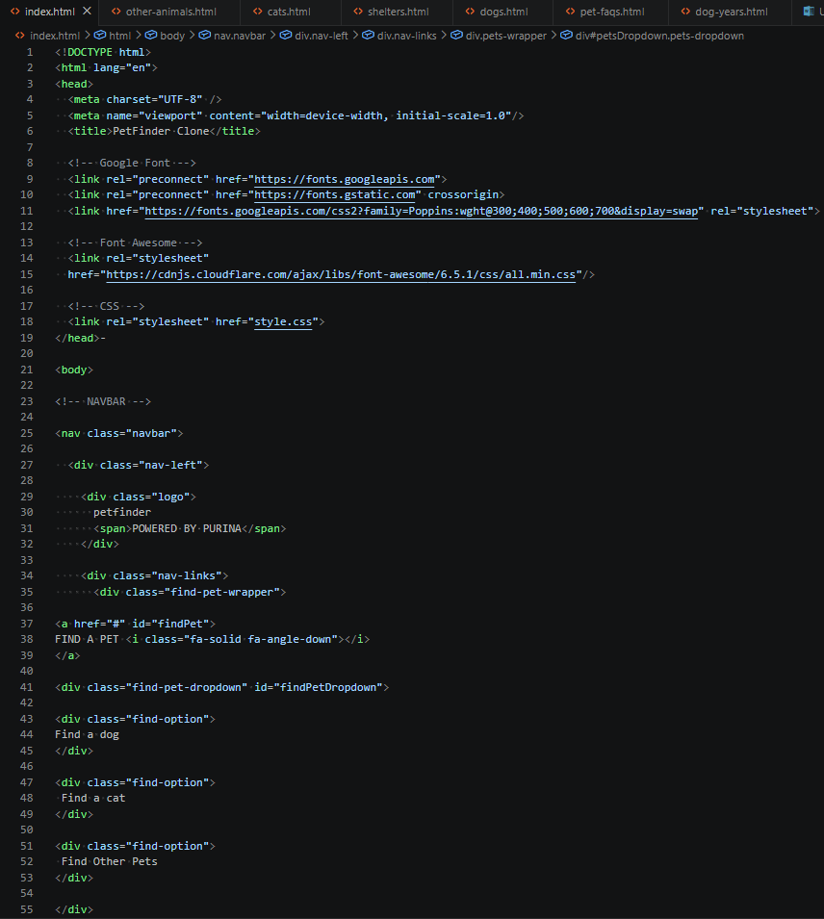
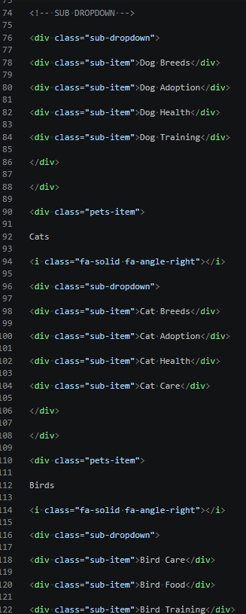
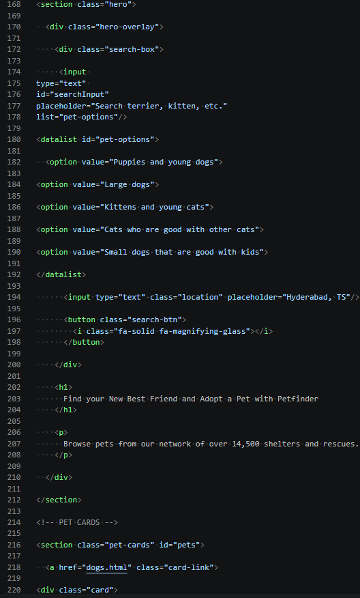
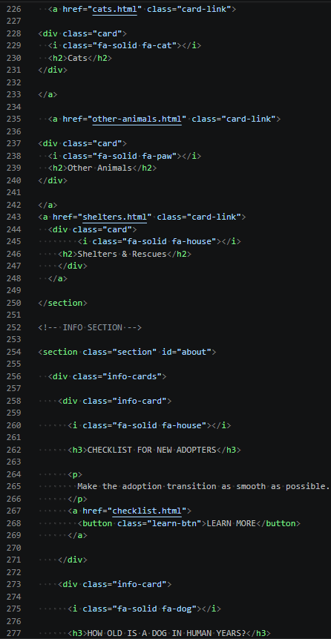
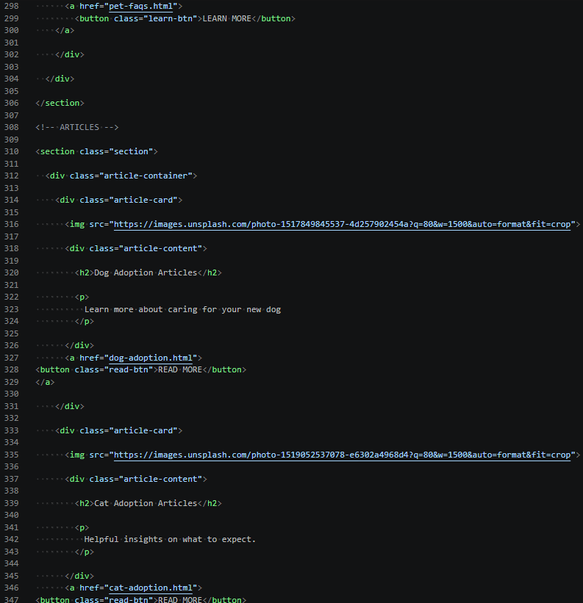

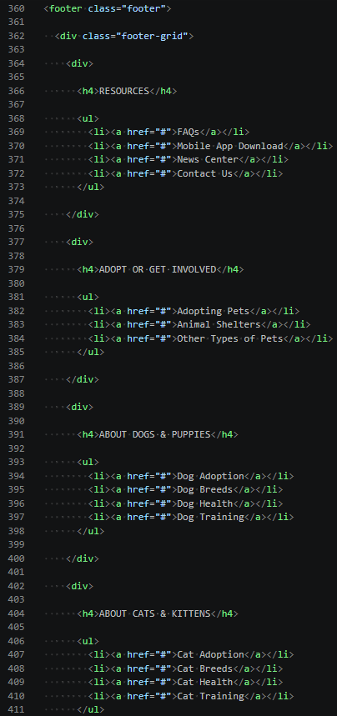
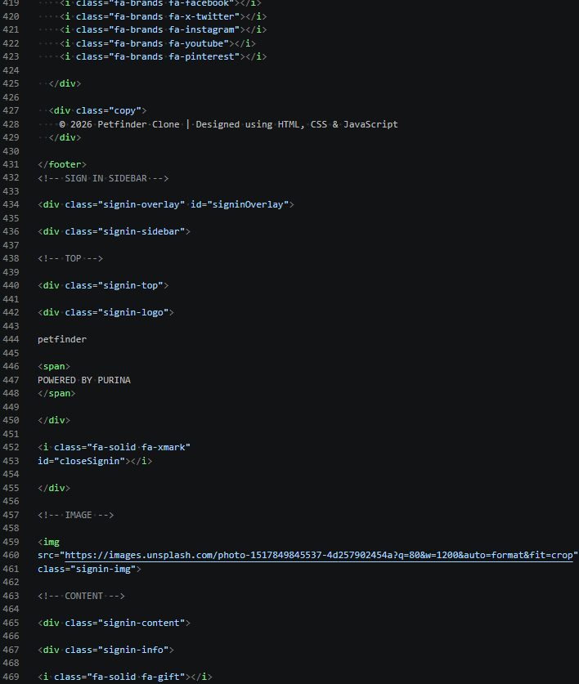
- Home Page
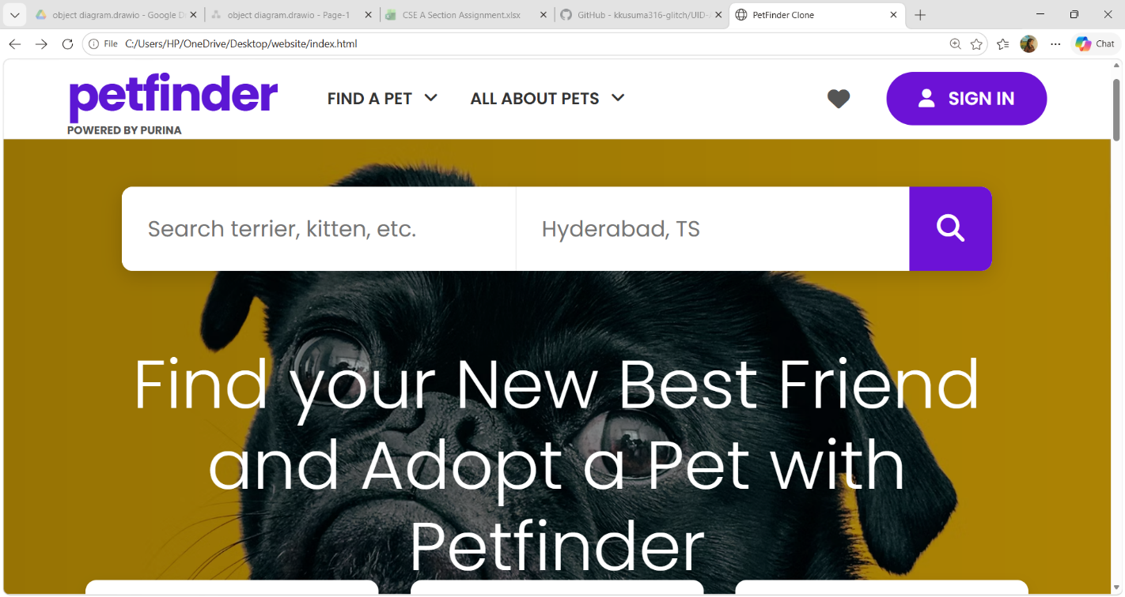
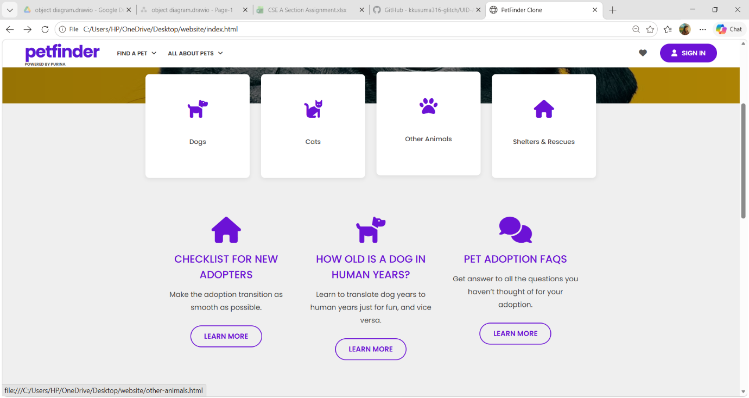
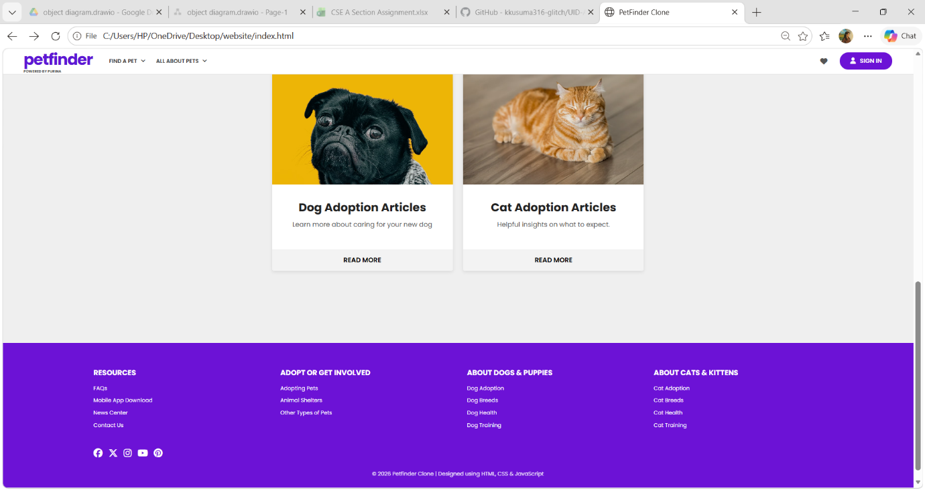

- Find a Pet dropdown
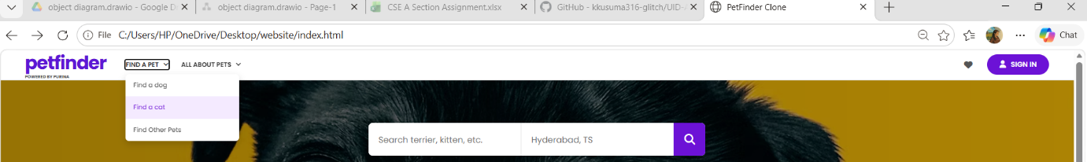
- All About Pets dropdown

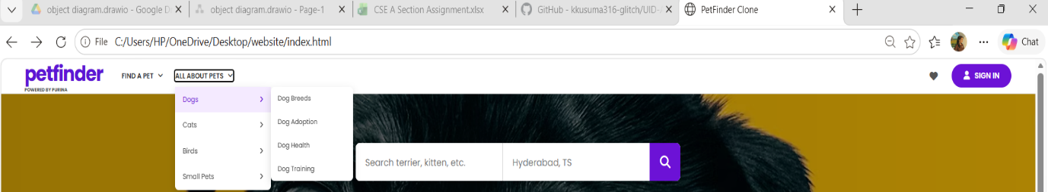

- Search functionality

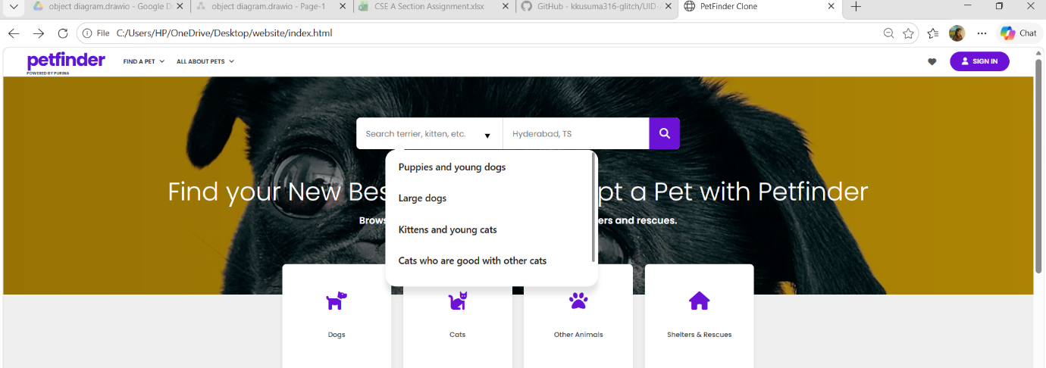

- SIGN IN Button
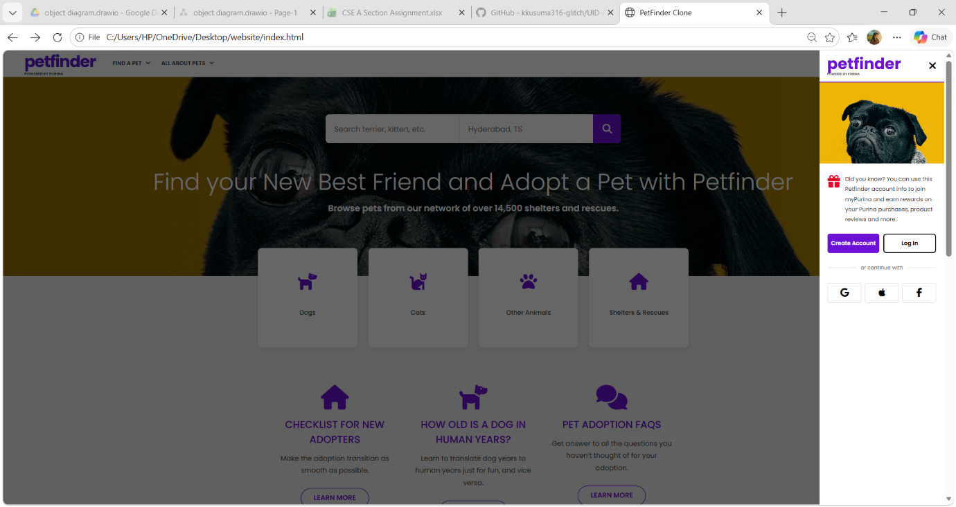

Pet Adoption Checklist Module
This section provides guidelines for new pet adopters including:
- Preparation before adoption
- Essential pet supplies
- Home readiness
- Pet care planning
Code
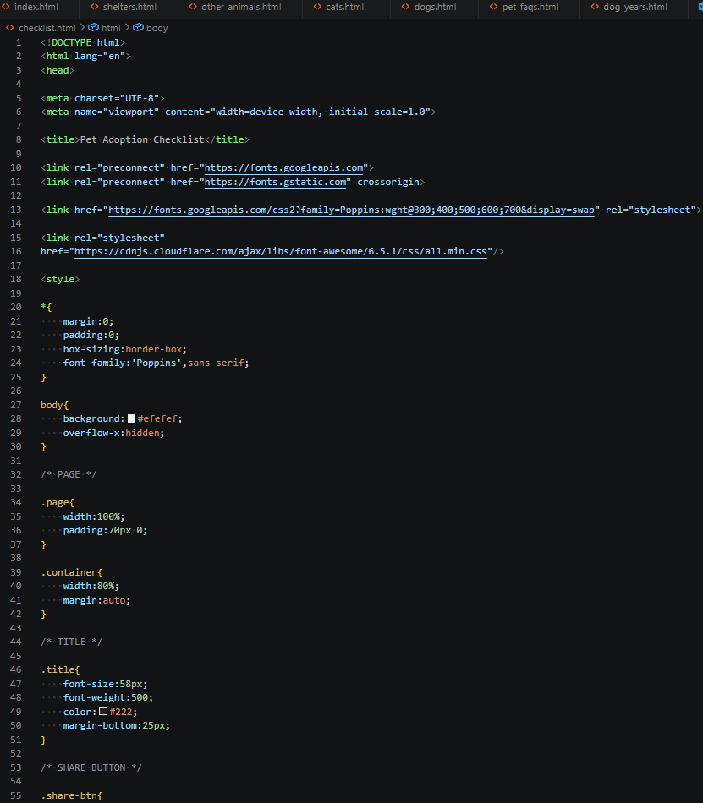
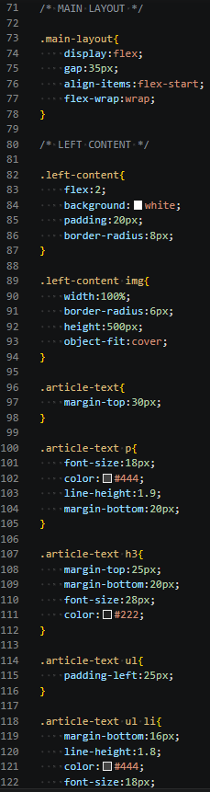

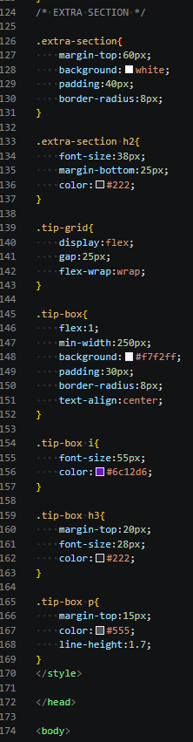
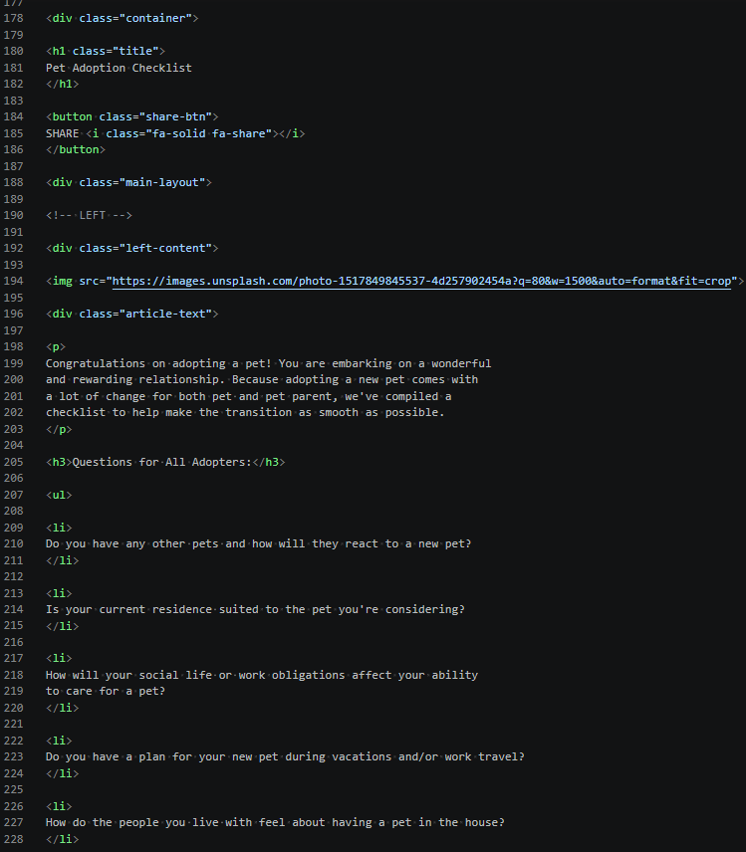
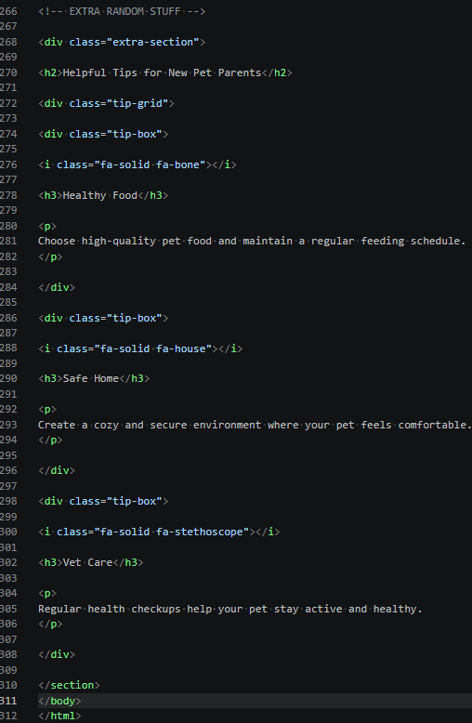
Output
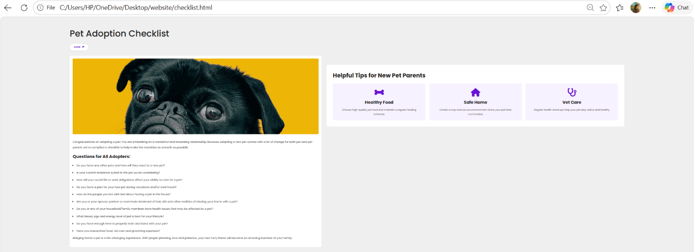

Dog Adoption Articles Module
This module contains educational articles about:
- Dog adoption process
- Puppy care
- Adoption tips
- Responsible pet ownership
Code
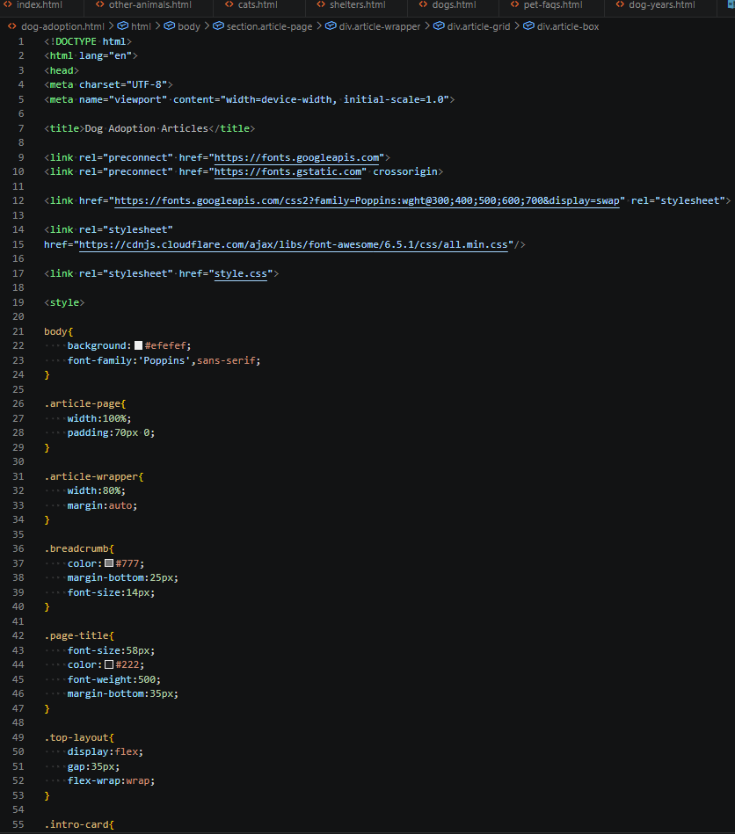
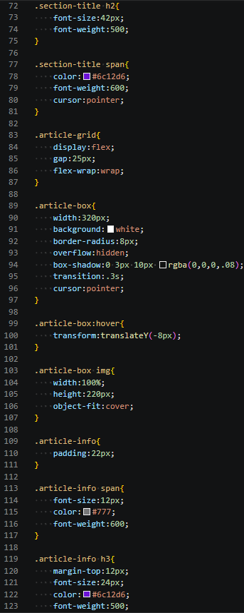
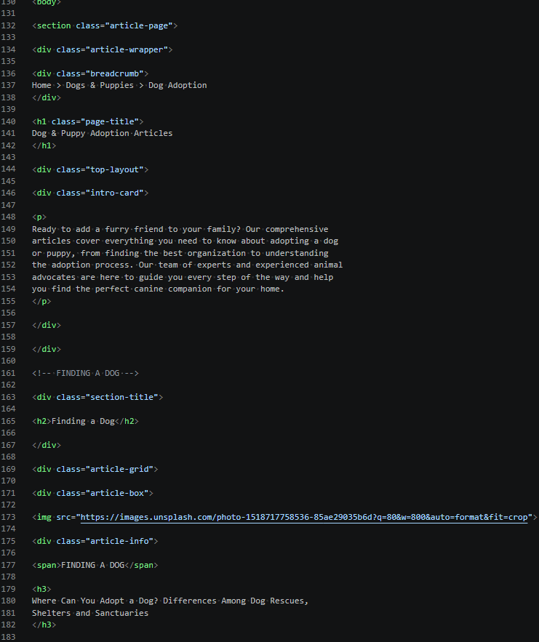
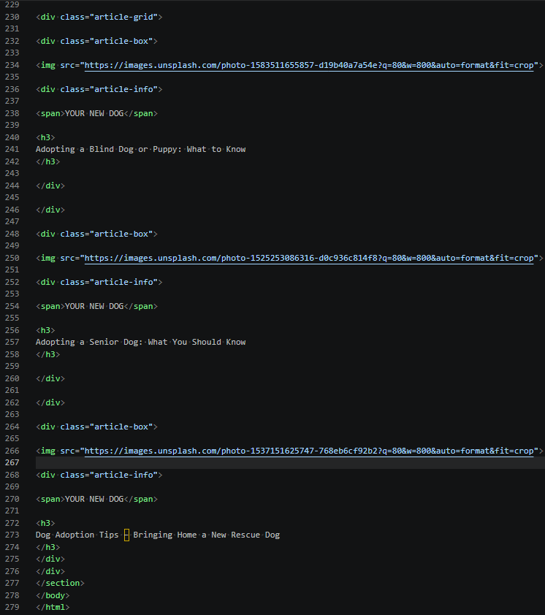
Output
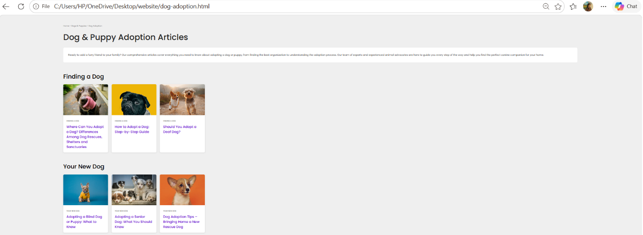

Cat Adoption Articles Module
This section provides:
- Cat adoption guidance
- Kitten care information
- Adoption recommendations
- Pet care articles
Code
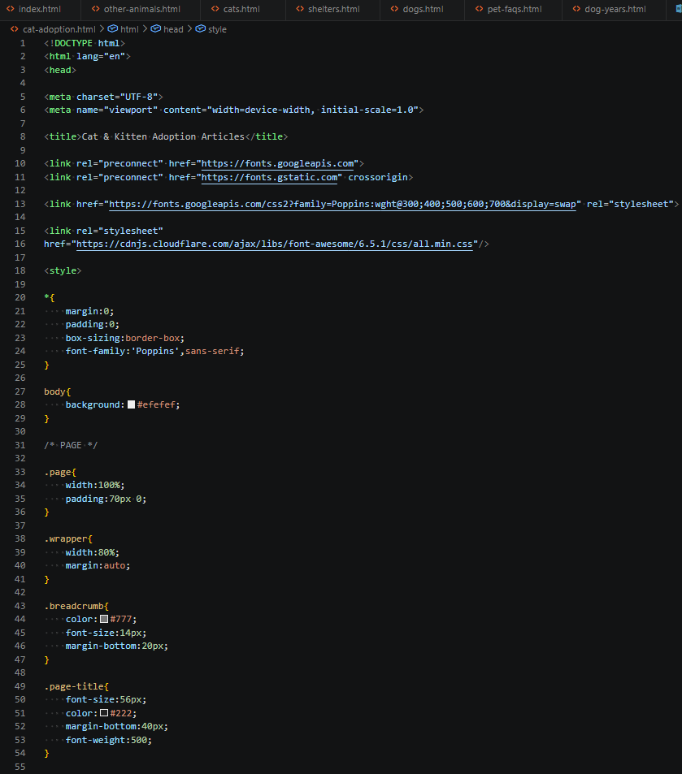
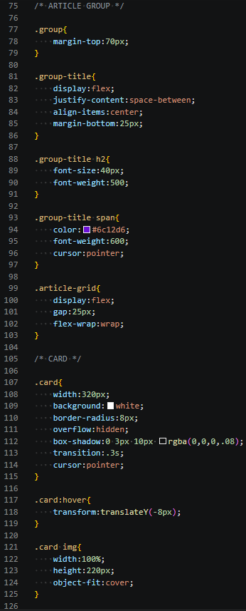

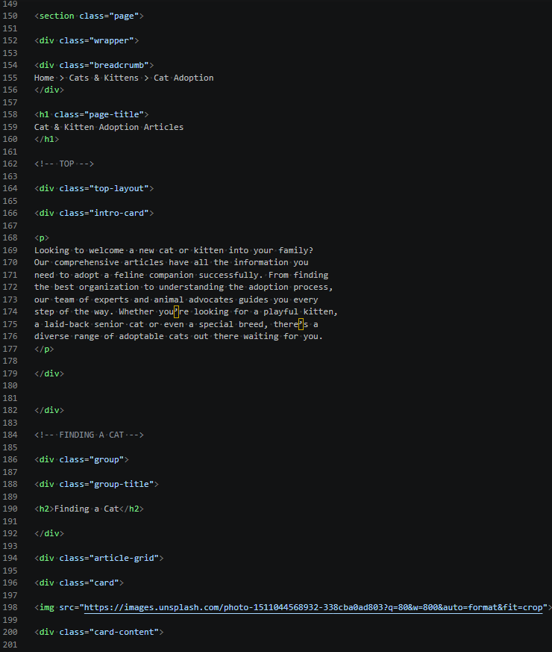
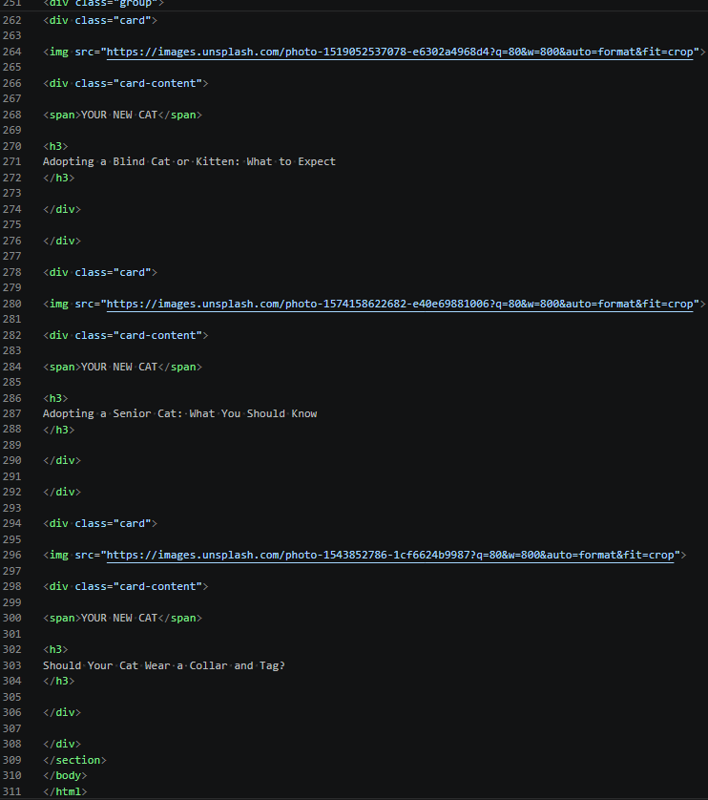
Output
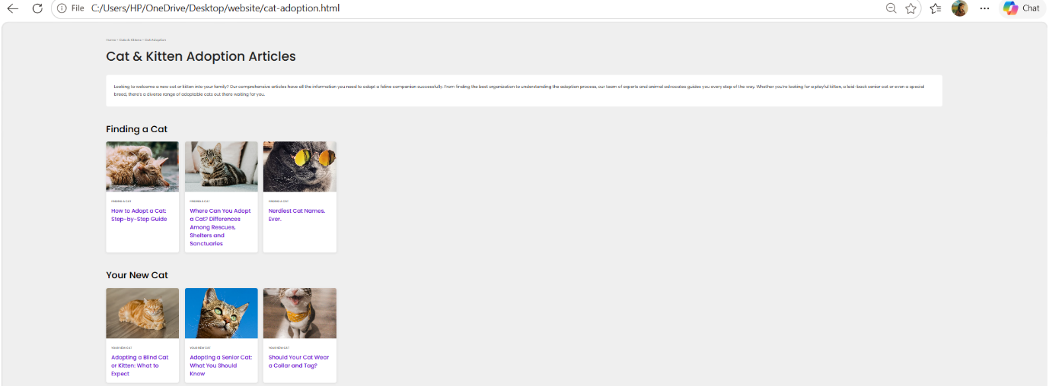

Dog Years Information Module
This educational page explains:
- Dog age conversion
- Human year comparison
- Dog life stages
- Fun pet facts
Code
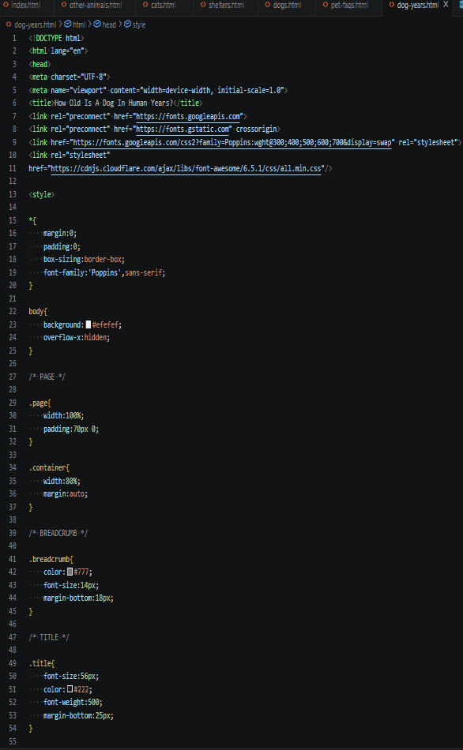
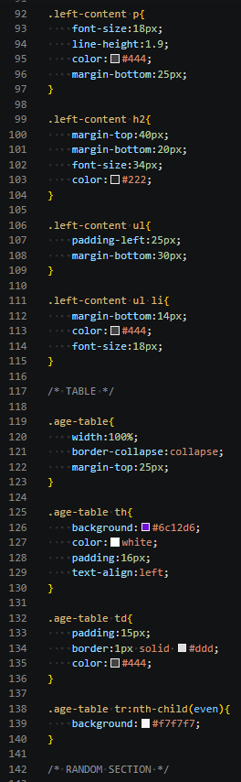
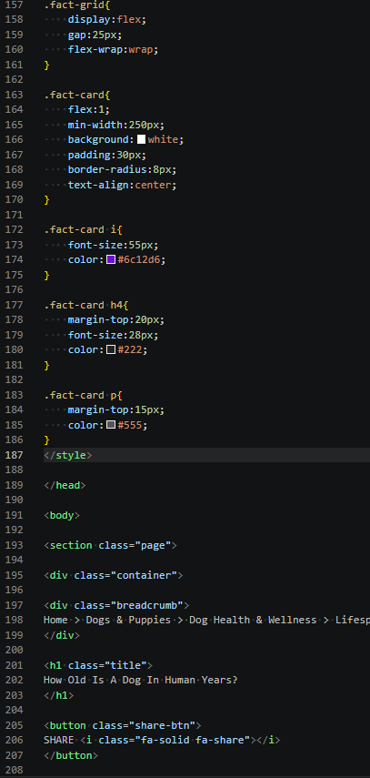
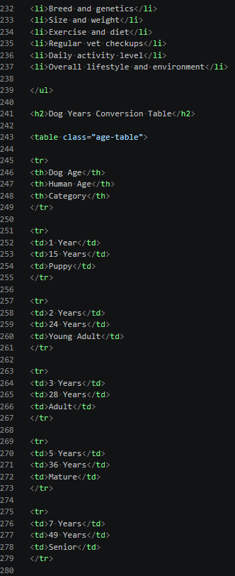
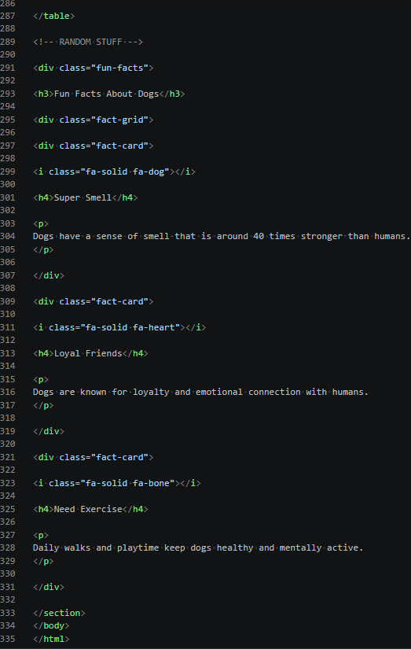

Output
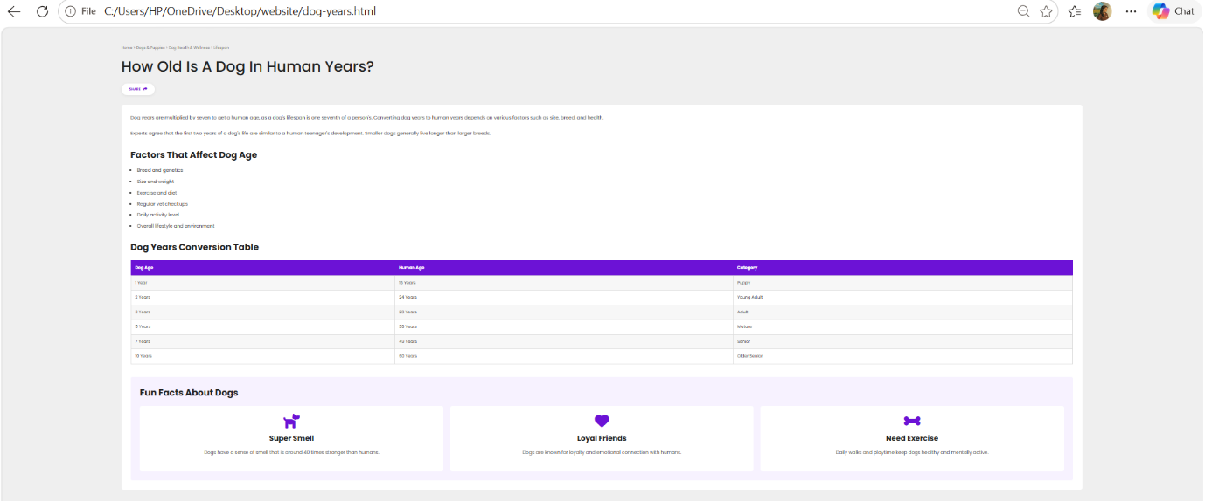

Frequently Asked Questions Module
This page contains:
- Common adoption questions
- Adoption procedures
- Pet care guidance
- Helpful resources
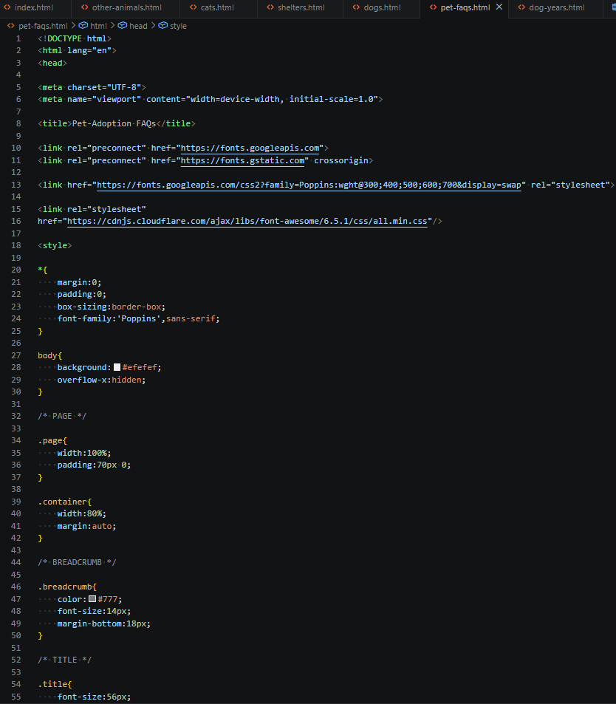
Code
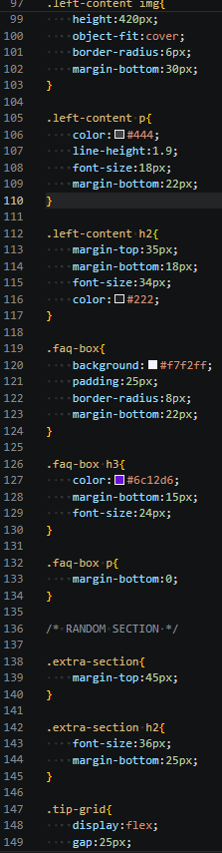
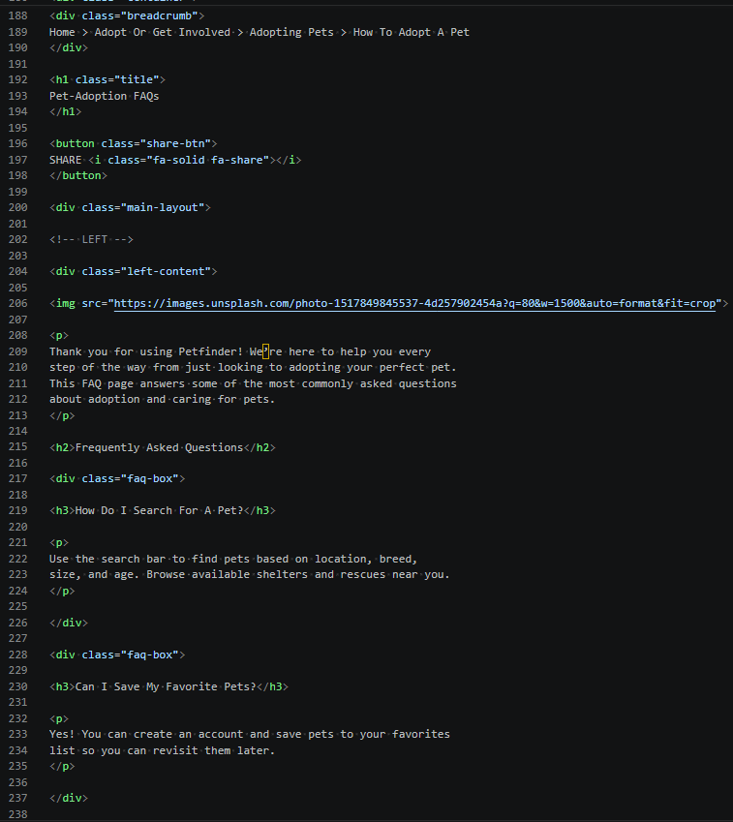
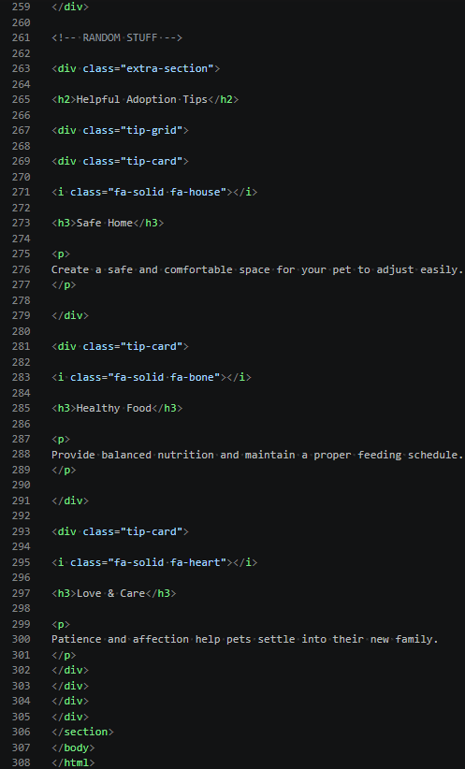
Output

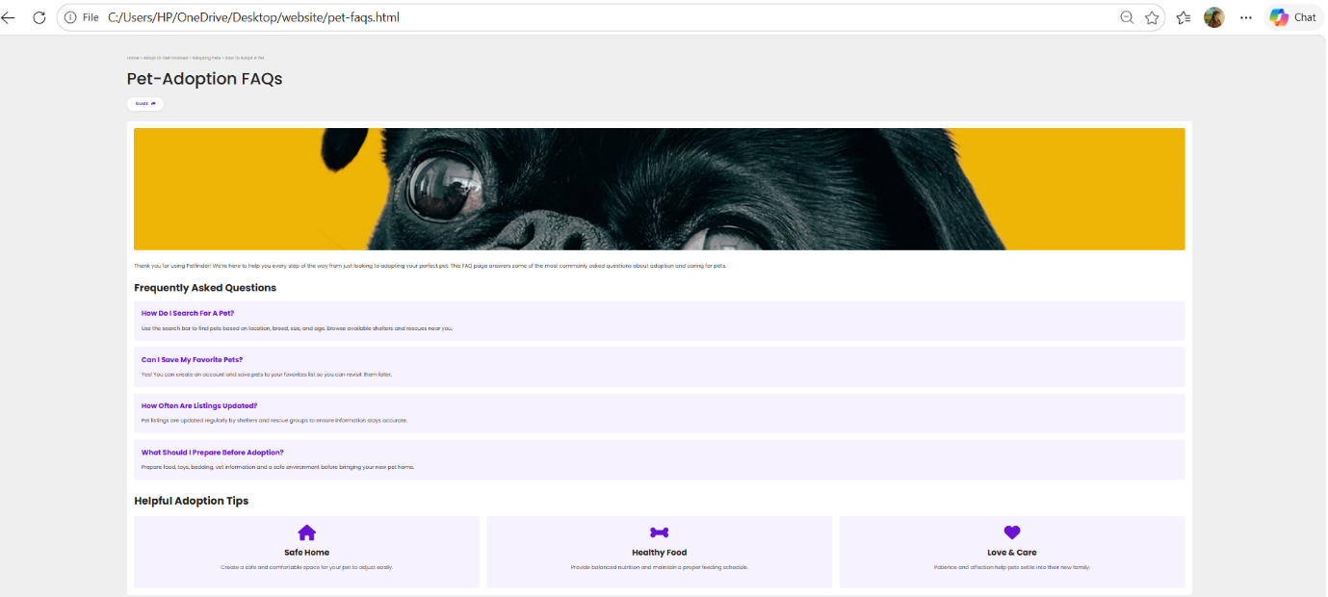

CSS Module
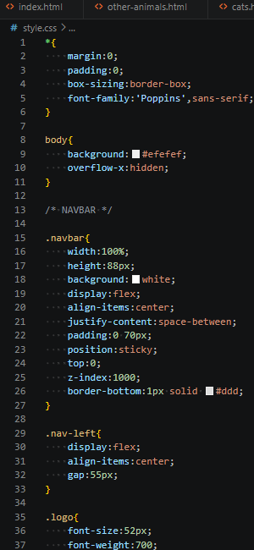
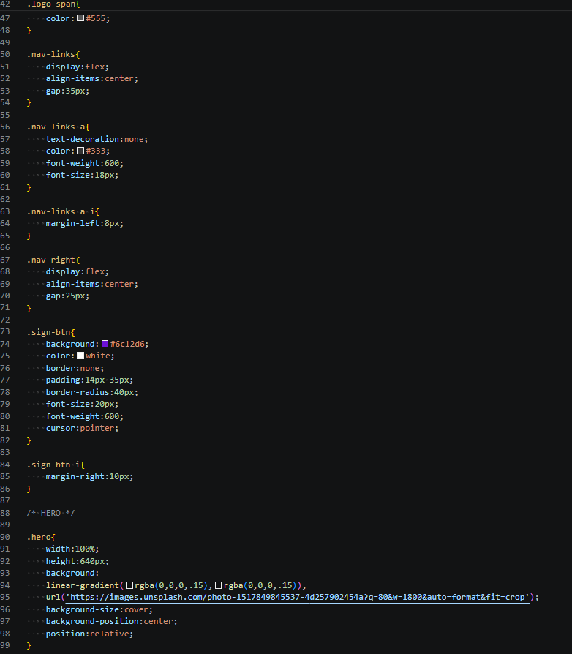
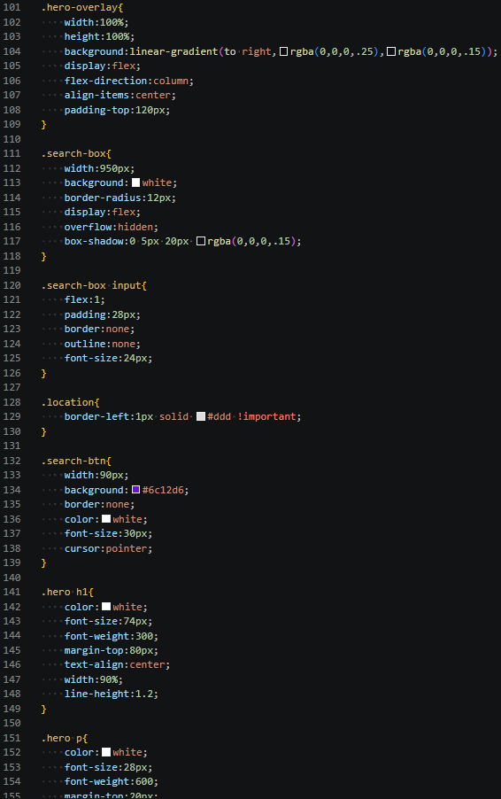
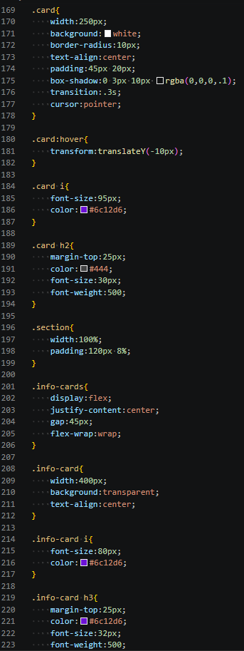
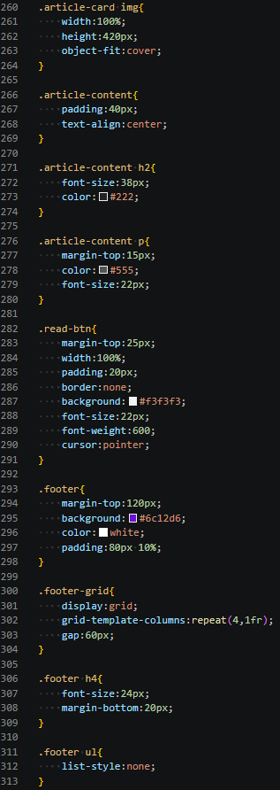
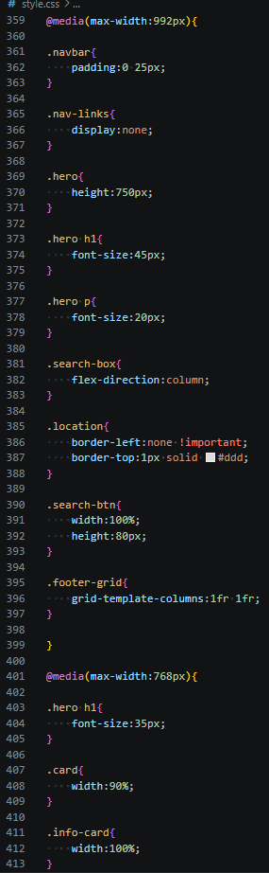
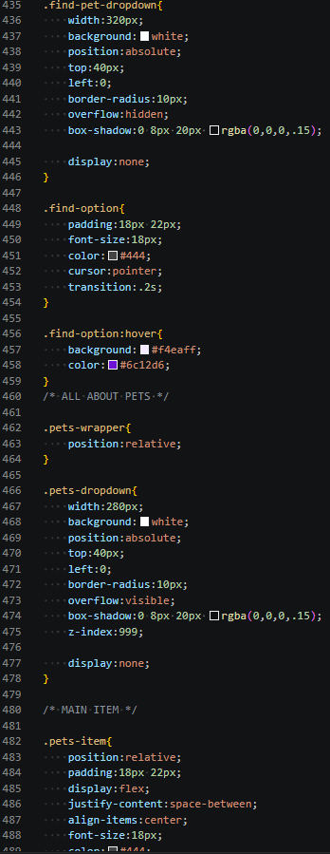
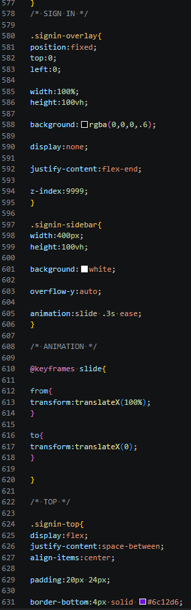

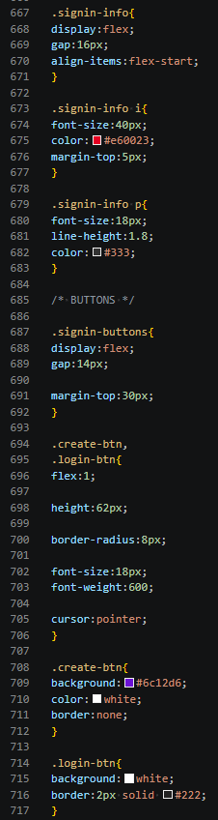
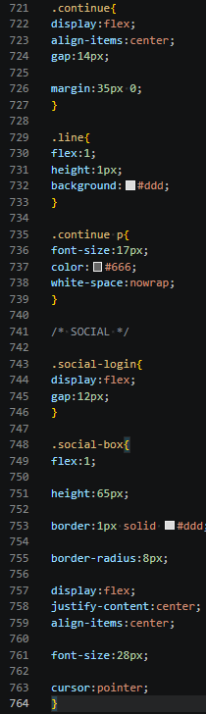
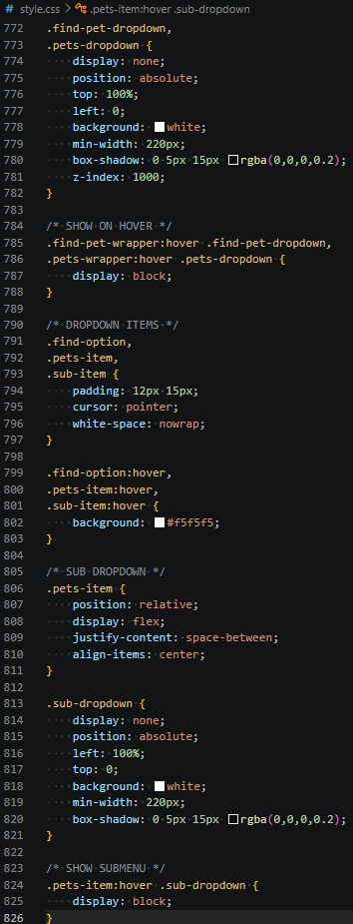

Explanation of tags
HTML
- <meta> – Defines character encoding and responsive viewport settings.
- <span> – Styles a specific part of text without affecting surrounding content.
- <datalist> – Provides predefined suggestions for an input field.
- <option> – Represents an individual selectable item in a datalist or dropdown.
- <label> – Associates descriptive text with a form input field.
- <br> – Inserts a single line break in the content.
- <strong> – Displays text with strong importance, usually in bold.
- <em> – Emphasizes text, usually displayed in italics.
- <main> – Contains the primary content of the webpage.
- <header> – Represents the introductory or top section of a webpage.
- <aside> – Contains sidebar or supplementary content related to the main page.
- <article> – Represents a self-contained piece of content such as an article.
- <form> – Collects and submits user input data.
- <textarea> – Allows users to enter multiple lines of text.
- <select> – Creates a dropdown list of options for users to choose from.
- <iframe> – Embeds another webpage, video, or external content within the page.
CSS PROPERTIES
- display – Creates flexible layouts using Flexbox and Grid.
- position – Used for navbar, dropdowns, and sign-in sidebar positioning.
- width – Sets the width of sections, cards, buttons, and images.
- height – Defines the height of elements like hero section and cards.
- background – Adds colors, gradients, and background images.
- color – Sets text and icon colors.
- padding – Creates space inside elements.
- margin – Creates space outside elements.
- border-radius – Gives rounded corners to cards, buttons, and dropdowns.
- box-shadow – Adds shadow effects to cards and menus.
- justify-content – Aligns items horizontally in Flexbox layouts.
- align-items – Aligns items vertically in Flexbox layouts.
- gap – Creates spacing between cards, icons, and menu items.
- font-size – Controls the size of headings, buttons, and text.
- font-weight – Adjusts text thickness for emphasis.
- text-align – Aligns text to center or other positions.
- transition – Creates smooth hover effects on cards and menus.
- transform – Moves elements during hover animations.
- z-index – Ensures dropdowns and sidebars appear above other content.
- @media – Makes the website responsive on tablets and mobile devices.

